TIPS, TRICKS & LINKS

- ½ teaspoon of bleach per 5 gal of water to purify it
- Eggs slathered in mineral oil will keep for up to 9 months
- Cotton balls with petroleum jelly will burn, makes a good fire starter
- Make your own laundry detergent ( see next page for recipe)
- Comet or borax kills bugs and even fire ant mounds
- Bounce dryer sheets (original scent only) will keep bees away from you
- Make a written emergency contact list ( useful if your phone dies)
- Make a family emergency plan (meeting places if you get separated)
- Trash bags cut open flat can be used in a pinch to cover windows and doors to help insulate your home further. ( I still suggest plastic sheeting its thicker and works better)
- Toilet paper rolls stuffed with lint from dryer will make a great firestarter

YOU SHOULD CARRY THE FOLLOWING ITEMS DAILY TO HELP IN ANY DISASTER
- Wallet with ID and insurance cards
- Cell phone
- cash (enough to buy essentials or a tank of gas remember people won’t be able to sell you stuff if their electric is out and you can’t use your debit or credit card so use your judgement on how much you should have on hand)
- Small flashlights (be sure to check batteries often)
- Small bottle of water or life straw
- Granola bar, trail mix, or hard candy
- Pen & paper
- Safety pins (trust me on this one)
- Pepper spray/ or taser
- Knife
- Back up battery pack (I carry one in my purse at all times and keep it charged! Wont help you if its dead!)

GOOD SOURCE FOR ADDITIONAL WATER IN YOUR HOME:
- Hot tub or pool ( can be used to flush toilets if you don’t have water)
- Water bob ( stores up to 130 gallons of water I have 1 per bath tub see link on links page)
- Hot water tank ( aprox 30-40 gal of water just sitting there, you should see a small spigot at the bottom to get the water out)

WHERE TO START FOR BEGINNERS:

- Take baby steps, and be sure to organize
- Start small! Don’t freak out about the long term right away, start with the essentials
  - 72 hours of supplies then work up to 7 days then 30 and so on!
  - FEMA RECOMMENDS 30 DAYS OF FOOD AND WATER

- Gather all of your important documents and put them in one safe place
- Develop a plan * this is so important because it can become complete chaos so be sure to have a plan of where to meet loved ones in a SHTF scenario
- Get back to basics: learn to start a fire, cook over a open flame, and how to secure your home
- Plan for power outages: be sure to stock up on candles (the dollar tree is a great place to get some super cheap), matches (to light candles and a fire), flashlights, lanterns and batteries to run these. ** I have rechargeable lights I got on amazon (see links page) they also double as battery packs and can light up an entire room with only one! **
- Determine the most likely disaster you will encounter in your area. (tornado, snow/ice storm, hurricane, fire, or all of the above) **I live in central Texas and have had to deal with all of the above, so plan accordingly**
- BUGGING IN- can sometimes be your best choice. Buy some plastic sheeting to cover windows/door use with duct tape to seal out dust and even the cold
- Plan for comfort and amusements (especially if you have kids) sometimes comfort foods, or objects can make a disaster a little easier to deal with. Some items I suggest: coloring books, games, deck of cards, crayons, teddy bear or blankey, puzzles, books!
- Get to know your neighbors, you never know what you can learn from them. Try to come together and prepare as a group, your life may just depend on someone near by. ( during the recent snow/ice storm here in central Texas I saw neighbors helping strangers with baby formula, and essential items! They even started a barter system which I thought was awesome!)
- Solar chargers are a life saver!! Along with back up battery packs I can survive playing on my phone for days! If you have littles and they have an ipad this can mean the difference of them being entertained or going stir crazy. I suggest having 1 battery pack per device in your home. And a means to charge the pack, hence the solar chargers. I try to keep my battery packs at or below 10,000 mAh capacity, this way my solar charger can charge them during the day. The larger the battery pack the larger the solar charger must be to charge it.

LINKS & ITEMS PAGE

WATER BOB- this is what goes in your bath tub that can hold up to 130 gallons of water.
Waterbob.com
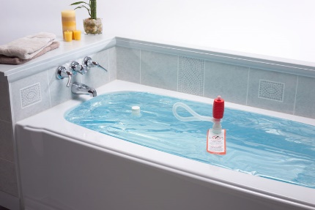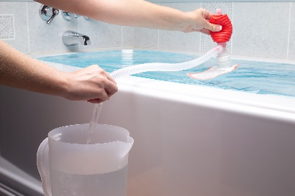

Lights- I bought these and love them it is aprox $30 for 2 lights they also double as battery packs in a pinch. 1 light will light up a large room even on the dim mode. Ive not had one die on me yet and I use them for other things pretty much all night long. They are aprox 2000 lumens on high and have 3 modes!
30W LED Work Light, 2 COB Rechargeable Flood Light, Portable 1500LM Job Site Lighting, Waterproof, 3 Lighting Modes for Outdoor Camping, Hiking, Emergency Car Repairing, Fishing Workshop, 2 Pack
Brand: LEDLightsWorld on Amazon.com
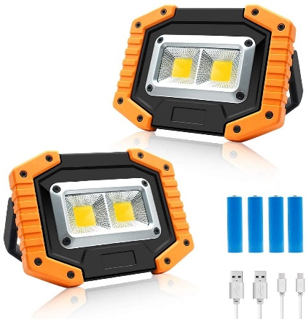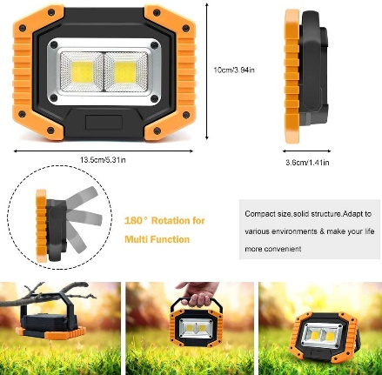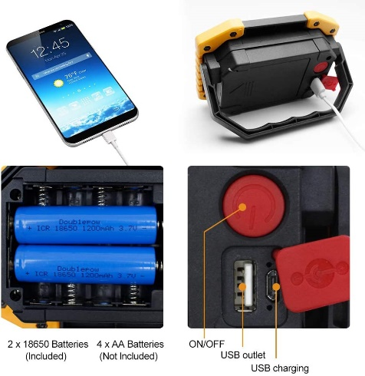

Solar Charger- this one is my choice but again up to you which one you buy. Its $40 on amazon and works amazingly well. ***buy one that is at least 10 watts*** smaller hand held ones are useless and don’t charge your phone like advertised. ( ive bought at least 5 or 6 different ones and they are all junk)!
Solar Charger Solar Panel Charger, VITCOCO 16W Foldable Solar Phone Charger with 2 USB Ports & Display Function for iPhone, iPad, Android, Power Bank, Waterproof Portable for Outdoor Camping
Visit the VITCOCO Store on amazon.com

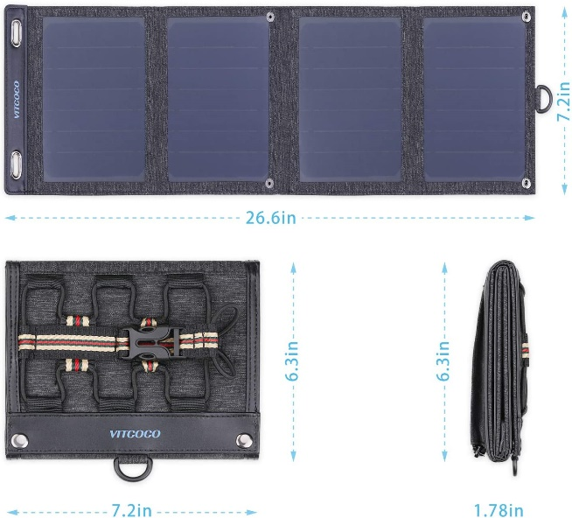

Battery Packs- I have purchased mine at Walmart or biglots one that is 10,000mAh should run you no more than about $20 each. Have one per device in your home is my suggestion. I buy them all the time and have multiple for each device. They are amazing to have in a long road trip where charging multiple devices is not an option or when camping, and again in any emergency.
Side note: (I work at a hotel and had a customer who was stuck with us during Hurricane Harvey. He was from Houston and couldn’t reach his elderly mother because her phone died and she had no way to charge it to call for help or to let her family know she was forced to escape her home due to flooding and was safe in a shelter. It was a solid 2 days before he was able to hear from her and know she was ok. This is a perfect example of why every person and every device should have one! This guest went to Walmart and bought his mother 3 packs. He stays with us quite often and was able to update me on her condition and their recovery after Harvey)
PLEASE NOTE THE ABOVE ITEMS ARE SUGGESTIONS AND I IN NO WAY AM THE SELLER OF THESE ITEMS AND I DO NOT RECEIVE KICK BACKS FROM SUGGESTING THEM TO OTHERS. I SIMPLY HAVE HAD GOOD LUCK WITH THESE ITEMS AND WANTED TO GIVE YOU AN IDEA OF WHAT I USE AND LOVE. IF YOU CHOOSE TO BUY SOEMTHING ELSE THAT IS YOUR CHOICE. I DO NOT ACCEPT RESPONSIBILITY FOR WHAT ITEMS YOU CHOOSE TO PURCHASE!
HOW TO MAKE YOUR OWN LAUNDRY DETERGENT
Make your own laundry detergent- 6 ingredients, this recipe makes a batch that will last you a year! Works in HE washers and with cold water too!
Ingredients:
1 (4lb/ 12 oz) box of Borax- found in the detergent isle
1 (3lb/ 7 oz) box of Arm & Hammer super washing soda – detergent isle
1 (3LB) container of Oxy Clean- detergent isle (this is optional but I highly recommend adding it)
2 (14.1 oz) bars of Zote soap- detergent isle (I like the pink for the scent but the white is fine too. You can also use Fels Naptha soap bars)
4 lb of Arm & Hammer baking soda – found in the cooking isle
1-2 (55oz) bottle of purex crystals fabric softener- or use 3-4 bottles of scentsy washer whiffs (my top choice) purex can be found in the detergent isle

The hardest most time consuming part is grating the soap bars. It looks like pink cheese once youre done. If you do not have a food processor you will have to do this part by hand. Use a large mixing bowl to grate into and using the fine side of the grater. Another option is to microwave the soap beforehand. First, cut the bar into chunks or slices. Pop it into the microwave for about a minute. It will expand…a lot… but then it is dry and just crumbles into tiny bits. The hardest part is now over and all that is left is to mix everything together. Use a very large bucket and take a layering approach to mix it easier. Take small amounts of each ingredient and layer it on top of each other, then grab a large mixing spoon (wooden works best) and mix. This method works better than dumping it all in and hoping it mixes well. This batch makes a ton! Now for the best part! You only need 1-2 tablespoons per load depending on the load size! Now the stroke of genius if you opted for the purex crystals for your batch… you can scoop the detergent right into your bottle and use the lid as a measuring spoon. There are 3 lines on the side of the lid and the middle one is approximately 2 tablespoons!!!

CHEAP FIRE STARTER TIP:

it’s a great fire starter.
“Fun cheap little prep I make with the kids for our bug out bags. Lint from the drier, half tube from TP roll and some petroleum jelly. Put wax on the top and bottom till ready to use. One good spark and this will light and burn great for 10 min or more.”
To make Grab a glob if jelly and cover the lint the best you can, you can even use cotton balls and stuff inside a toilet paper roll! Then
Just melt a candle over the top until it's all covered. Than when you’re ready to use simply break a hole in the wax, As it burns, the wax helps keep it going slow.

Awesome cheap to make fire starters!

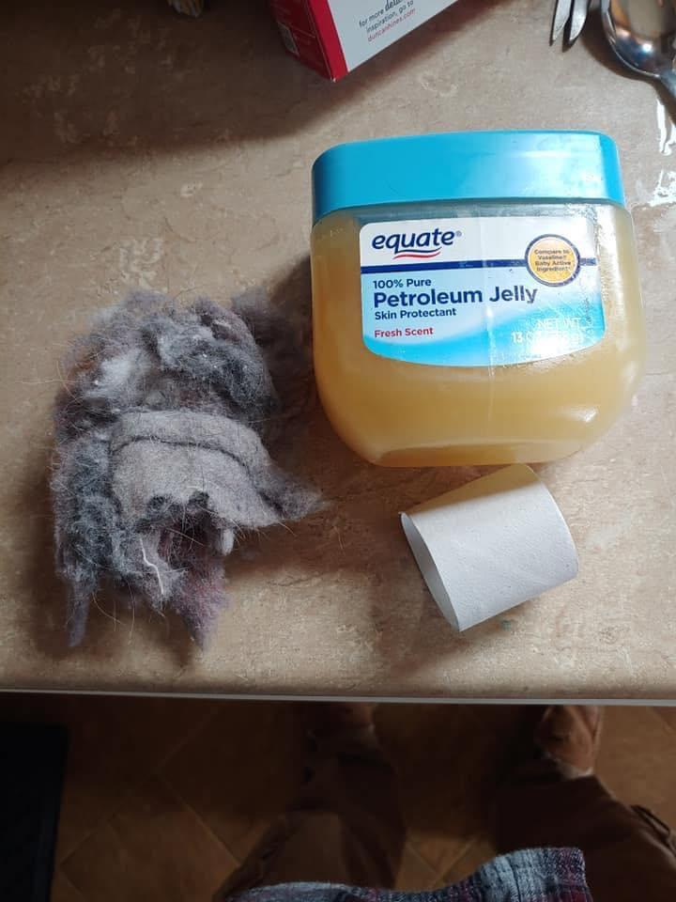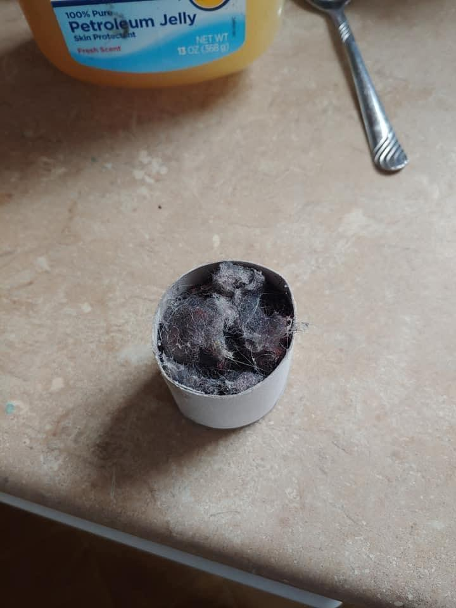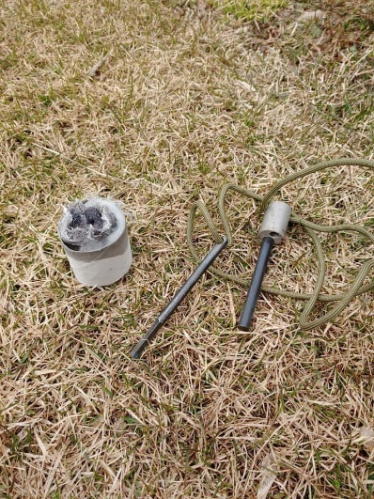

TIPS FOR THINGS IN YOUR BUG OUT BAG MOST PEOPE DON’T THINK OF!
These are items that are probably not on any bug out bag list. I loved some of the suggestions that came from fellow preppers. These are the ones I wanted to share with you. Ill be adding to this regularly so keep checking back!
- Ice pick- for me its to puncture gas tanks for fuel. If things are that bad any abandoned vehicle will have some sort of fuel, and I don’t want to mess with a syphon hose or anything that will take longer than necessary to get what I need and be gone! A small hole with a controlled stream can be easily put into a small gas can for fuel in my vehicle or for a fire whatever I may need it for.
- Mosquito netting! Never know when you need to keep the bugs off of you. There is a cheap one that can be tied out for only about $10- $11 on amazon or you can get just a sheet of netting for less. Up to you.

