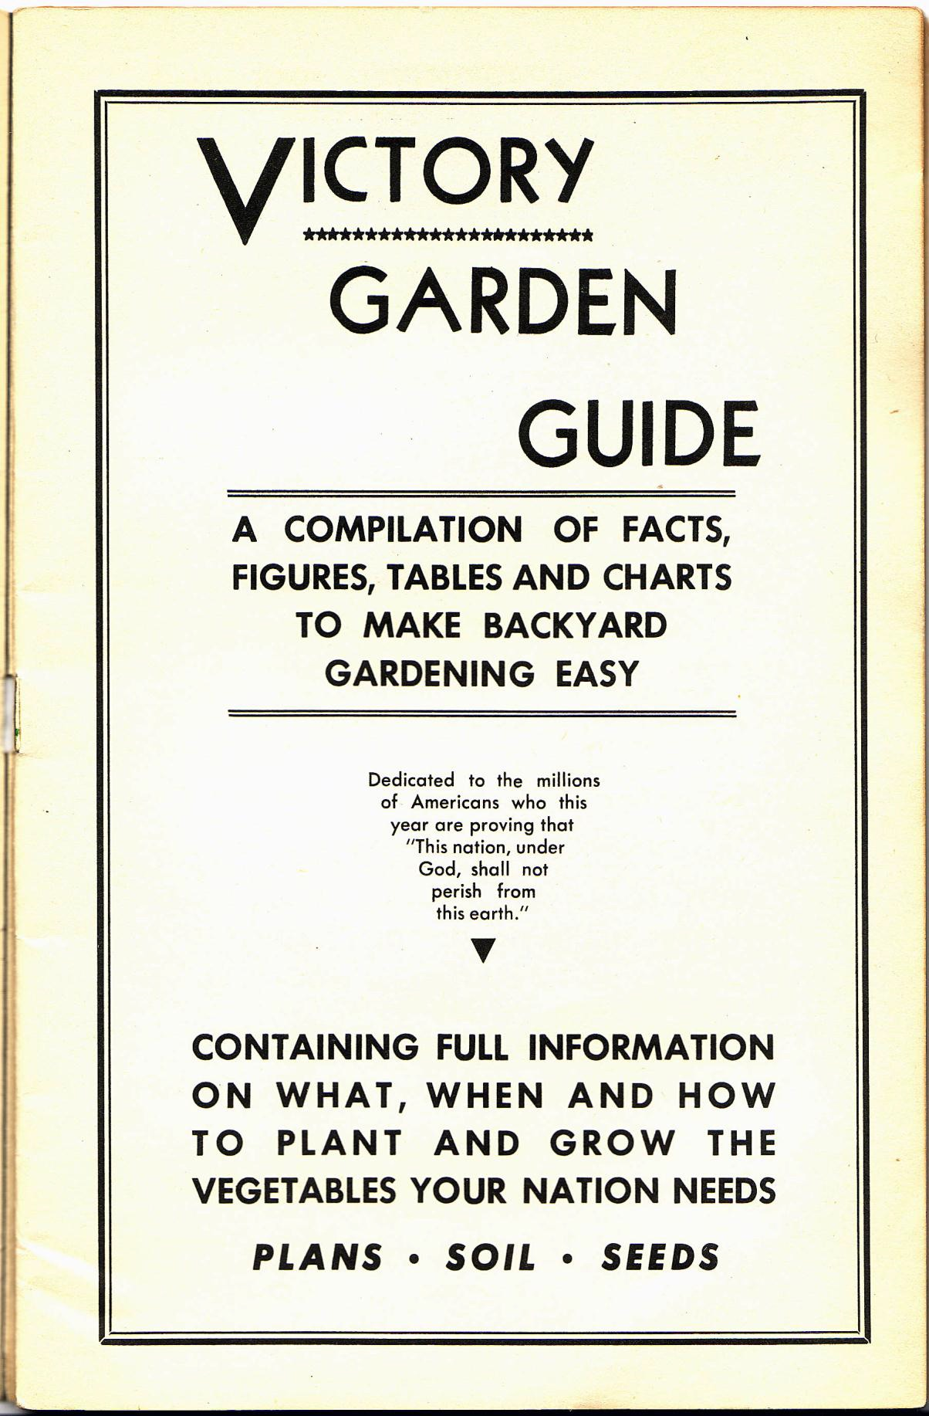
Introduction

Department of Agriculture
Washington

Every town, city and suburban family with a plot of sunny, open space of suitable soil, or access to a community or allotment garden, can make an important contribution to our national food program and our war effort by growing a victory garden.

This year we need more food than ever before in history. We need it for our men at the battlefronts, and those in training. We need it to keep the folks at home healthy and strong.

Farmers broke all records in food production last year for the third time in succession. They are ready to do their level best to produce even more this year. All they can possibly produce of most foods will be needed. In many cases, more than can be produced on our farms will be needed. We simply can't get too much of some kinds of food. Every farm family, of course, will be expected to have a garden for home use and, if possible, to provide extra supplies of vegetables for nearby markets.

The entire national food situation will be tremendously helped, and our total food needs more easily supplied, if those who have suitable ground will grow all the vegetables required for the family. Special attention should be given to green and leafy vegetables, yellow vegetables and tomatoes, because these kinds bring valuable vitamins and minerals right to the family table."
home grown vegetables, wisely selected as to selected as to variety and properly cared for, not only will provide nutritious food for the family table, but will also lessen the drain on commercial stocks of food in stores and ease transportation problems. Growing a garden also will provide the city, town and suburban resident with an interesting, useful outdoor activity at a time when opportunities for normal recreation are limited.

However, it is important to remember this ñ select a plot that will grow a good garden, and then tend it faithfully. We cannot afford to waste seed, fertilizer, insecticides, and labor in 1943. Make your plans carefully and grow a victory garden even if it is a small one. It will help you and it will help our country. And, remember, home canned vegetables will supplement ration allowance of canned goods.

Claude R. Wickard
Secretary of Agriculture

This statement from Secretary Wickard does not constitute an endorsement by the Department of Agriculture of this book or the products of its sponsor.

Copyright 1943
D. H. Bedford, New York
Table of Contents
YOU MUST HAVE A GARDEN THIS SUMMER! 3
HOW TO LOCATE YOUR GARDEN 3
HOW BIG SHOULD A GARDEN BE? 4
DON’T PLANT TOO EARLY THIS SPRING! 5
YOU WILL NEED THESE TOOLS 10
THESE VEGETABLES ARE EASIEST TO GROW 13
No. 1 PLAN FOR SMALL GARDEN 14
DIAGRAM OF PLAN No. 2 16
No. 3 PLAN FOR LARGE GARDEN 18
START A COMPOST HEAP 20
YOU SHOULD HAVE A COLDFRAME 21
PREPARATION OF THE SOIL 22
HOW TO SOW YOUR SEEDS WITH CARE 25
CULTIVATION ENCOURAGES GROWTH 26
PLANTING TIME AND MATURING TABLE 27
SUCCESSION OF CROPS VERY PROFITABLE 28
CERTAIN VEGETABLES REQUIRE SUPPORTS 29
FACTS ABOUT YOUR FAVORITE VEGETABLES 31
VITAMIN VALUES IN VEGETABLES 33
THE USE OF INSECTICIDES 34
REMEMBER THE IMPORTANT "DO'S" 35
REMEMBER THE IMPORTANT "DON'TS" 36
TIPS FOR GARDENERS VICTORY 37

YOU MUST HAVE A GARDEN THIS SUMMER!
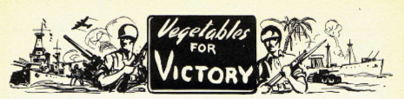
You may not be able to carry a gun or drive a tank, but you can grow food for Victory! The scarcity of food is no longer something that may happen? it is here RIGHT NOW!
Canned, dried and frozen vegetables have been rationed. Some experts estimate that we will receive about 70% of the amount that We had last year. WHY NOT RAISE YOUR OWN? Have as many of them as you want! Have the finest tasting vegetables a king could have, gathered fresh from your own garden.
GARDENS A PATRIOTIC DUTY
Our Government urges you to raise to raise food because in so doing you will save metal that would have been used for cans. You will save the fuel that would have been used to carry the food to your local store. You will save the space on railroad trains that is so vitally needed for the transportation of ammunition and supplies for our armed forces. You will have the satisfaction of knowing that you are doing your part in helping to win the war.
YOU WILL SAVE A LOT OF MONEY
For $2 or $3 you will be able to buy enough seeds and plants for the average family. These will supply you all summer long and well into the fall with practically all of the vegetables you will need, plus some for canning.
You know how high the prices of have gone right now. They will probably go higher next summer. Your own garden is the answer! NO other investment will bring you big returns.
GARDENING IMPROVES YOUR HEALTH
"What you need is exercise" has the recommendation of many a doctor when people have asked what the matter with them. Gardening will supply the finest exercise any doctor could ask for. It is all done outdoors in the pure fresh air and sunshine. It will help you get in better physical shape than you have been in for years. It will awaken an appetite and make you sleep more soundly.
A NEW HOBBY FOR MILLIONS
A fascinating game! That's what gardening is. From the time the green seedlings break through the crust of the earth, to the great day when you sit down to your first meal of vegetables grown by own efforts, you will have one thrill after another as Mother Nature unfolds her miracles. Whether it's the dew on the leaves early in the morning or the fragrance that hovers over every garden after a summer shower, you discover many new pleasures, and wonder why you didn't have a garden long ago.

HOW TO LOCATE YOUR GARDEN
The ideal location, of course, right in your own back if that is possible. Next best is that empty lot next door, if you are fortunate to have one there. Ask the owner for permission to use it. It's wartime? he will be glad to tell you to go ahead. Don't go too far away from your home. Remember that you will have to carry your tools and other material each time you to work. The fact your garden will require watering is another reason to locate it near as possible. A handy water faucet to you can attach a hose is much preferred to running back and forth with a watering-can. If the summer is dry the availability of a hose will be absolutely

REQUIREMENTS FOR A GOOD GARDEN

PLENTY OF GOOD SUNSHINE
It's the Sun that makes vegetables grow, so be your garden well away from trees. They will not only keep the sun away, but their roots will steal moisture and nourishment from the ground. A simple rule to follow is to keep your garden many feet away from a tree as the tree high. For if the nearest tree is twenty feet high, keep the edge of your garden at least twenty feet from its trunk. The same rule to any nearby shrubs or bushes

GOOD, DEEP TOP SOIL
Good top soil is just as important as sunshine. You cannot grow crops where the top soil has been removed or where it is only a few inches deep. A depth of at least 8 inches is desirable. It should be quite free of rocks and stones or you will find it very difficult to work. It should be comparatively level or the soil is apt to wash away. A lawn that has been turned over makes one of the best soils you could have. Whatever the nature of your top soil may be, it can be greatly improved by your own efforts as explained on page 18

DRAINAGE NECESSARY
Most level or slightly sloping plots of ground have good drainage. Low lying ground that remains wet for any considerable length of time after a rain is not satisfactory. Ground that is always swampy and wet, is of course, no place for a vegetable garden.
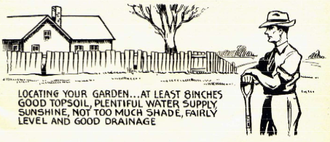

HOW BIG SHOULD A GARDEN BE?

There are factors to be considered before you decide how big your garden should be.

FIRST- How big is the best available space? You may not want to use all of it but you may also have to be satisfied with a smaller space than you would like to have. You can have your garden in two sections if that is the only way you can get sufficient space for your plans. The closer these sections are together the easier they will be to attend.

SECOND- How experienced are you at gardening? While there is nothing mysterious or difficult about raising vegetables, a beginner will not be able to work as fast as an experienced gardener, or he as good a judge of how much work he is cutting out for himself. He may find later that he is unwilling or unable to do the necessary amount of work to bring the crops through to their ripening stage. Remember, too, that a modest garden will supply you with a surprising quantity of vegetables. Of course, if too much ripens at once for your own use (and you don't can it) you can always share it with your neighbors (but it does mean extra work for you). Review the plans of various size gardens as shown on pages 10 to 15, and select one that you can successfully handle. If you are experienced you need little guidance. Undoubtedly you will plan one big enough to meet your, current needs, as well as supply you with a surplus for canning or storage. We also advise the beginner to stick to the easy-to-grow annuals and leave the perennials, such as asparagus, strawberries and rhubarb to the experienced gardener. Of the annuals it is well to leave out of your plans such vegetables as cauliflower, watermelons and celery because they are somewhat more difficult to grow.

THIRD- Plan to grow the things that you and your family like best. Radishes are fine for people who like them, but why grow them if you don't?

FOURTH- Plan to grow a succession of crops. This is the most important reason for having a definite plan on paper before you start. It is the only way to insure a steady supply of fresh vegetables all season. Where your space is limited such a plan will also help you to get two or three quick growing crops from a single row.

FIFTH- Consider the point value of rationed canned vegetables. Certain crops are going to have a high point value and will take more of your coupons to buy. At the time of this writing it is forecast that Carrots, Beets, Corn and Spinach will have high point values and should therefore be included in your plan. Study these factors carefully before you decide on your plan.
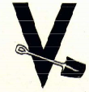

DON’T PLANT TOO EARLY THIS SPRING!

Check your location on this map for date of last spring frost
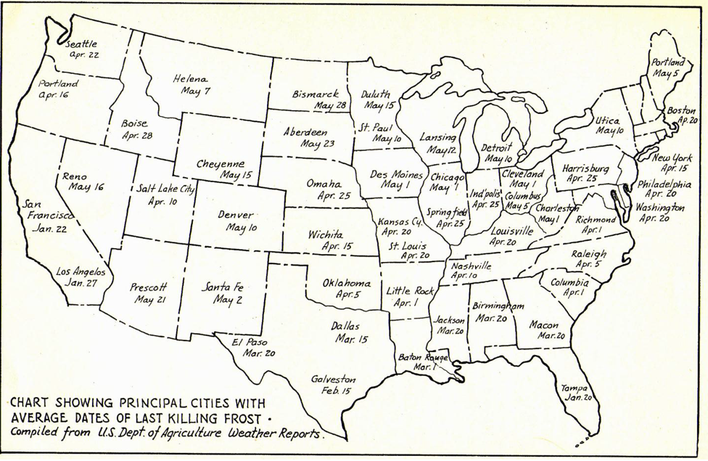

The dates are those of the average last Spring frost. Check your location, turn to page 23, and note planting dates which are based on April 15th as last frost. Adjust to your locality by adding or subtracting difference in weeks between that date and date shown above for your section of country.

State | City | Avg. date of last killing frost
Alabama | Birmingham | Mar 20
Arizona | Prescott | May 21
Arkansas | Little Rock | Apr 1
California | Los Angeles | Jan 27
California | San Francisco | Jan 22
Colorado | Denver | May 10
Florida | Tampa | Jan 20
Georgia | Macon | Mar 20
Idaho | Boise | Apr 28
Illinois | Chicago | May 1
Illinois | Springfield | Apr 25
Indiana | Indianapolis | Apr 25
Iowa | Des Moines | May 1
Kansas | Wichita | Apr 15
Kentucky | Louisville | Apr 20
Louisiana | Baton Rouge | Mar 1
Maine | Portland | May 5
Massachusetts | Boston | Apr 20
Michigan | Detroit | May 10
Minnesota | Duluth | May 15
Minnesota | St. Paul | May 10
Mississippi | Jackson | Mar 20
Missouri | Kansas City | Apr 20
Missouri | St. Louis | Apr 20
Montana | Helena | May 7
Nebraska | Omaha | Apr 25
Nevada | Reno | May 16
New Mexico | Santa Fe | May 2
New York | New York City | Apr 15
New York | Utica | May 10
North Carolina | Raleigh | Apr 5
North Dakota | Bismarck | May 28
Ohio | Cleveland | May 1
Ohio | Columbus | May 5
Oklahoma | Oklahoma City | Apr 5
Oregon | Portland | Apr 16
Pennsylvania | Harrisburg | Apr 25
Pennsylvania | Philadelphia | Apr 20
South Carolina | Columbia | Apr 1
South Dakota | Aberdeen | May 23
Tennessee | Nashville | Apr 10
Texas | Dallas | Mar 15
Texas | El Paso | Mar 20
Texas | Galveston | Feb 15
Utah | Salt Lake City | Apr 10
Virginia | Richmond | Apr 1
Washington | Seattle | Apr 22
West Virginia | Charleston | May 1
Wisconsin | Lansing | May 12
Wyoming | Cheyenne | May 15
 | Washington D.C. | Apr 20

YOU WILL NEED THESE TOOLS

SELECTION IMPORTANT
You need many tools, but the ones you get should be of good quality. They will make your work much easier and will last much longer. Buy tools that suit your strength. Obviously, a woman not used to gardening will not want tools as heavy or big as those suited to a strong man.

A WHEELBARROW
Be sure to have one. No other tool will save you so much labor and time in garden work. Almost any type will do.

A SPADING FORK
For general digging. It has four flat prongs. It is lighter and better than a spade for turning over and breaking up lumps of soil. You also it for manure and compost and for digging up potatoes and other crops in the fall.

A GOOD SPADE
Also, for general digging and shoveling. Be sure you get one with a blade ten or twelve inches long. One about six or seven inches wide is right men? four or five inches for women.

AN IRON RAKE
For leveling off ground that has been loosened; for stones and trash. Get one that has ten to fourteen iron teeth, that curves in. Most people prefer the bow type.

A HOE IS ESSENTIAL
For weeding, cultivating and planting. You also use it for hilling up corn and other vegetables. The common garden type hoe is best.

A CULTIVATOR FOR SPEED
Better than a hoe for cultivating. Does more work with less effort. Once the plants start to grow you will use it more than any other tool. Get the speedy prong type. For larger gardens get one with adjustable tynes. Very large gardens should have a wheel cultivator.

STRONG CORD GUIDE LINE
Essential in laying out straight rows. Put a knot in the line every three feet to help you make measurements quickly. Tie stakes at each end.

HOSE AND SPRINKLER
No garden is complete without one long enough to reach all corners. A good rotating arm sprinkler will save you lots of time and do a better job than you will by hand.

SMALL TOOLS
Make a dibble an old tool handle and use it to make holes for transplants. You will need a small trowel. A sharp knife serves many needs.
DUSTERS, SPRAYERS
You will need these before the season is over to help you control insects and plant diseases.

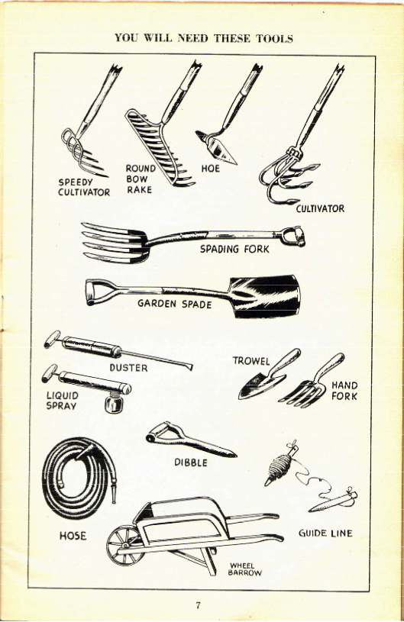

THESE VEGETABLES ARE EASIEST TO GROW

If given the proper care, the right soil and climatic conditions, almost any vegetable you mention can be raised successfully. Great strides have been made in the last ten years by seed growers in developing strains of vegetables that can withstand the attacks of certain diseases and even hold their own against some insects.
Generally speaking, the annual vegetables (those that must be planted each year) are easier to grow and require less attention than the perennials, such as asparagus, rhubarb and strawberries. But even with the annuals it is well for the beginner to leave out of his plans certain vegetables that are subject to persistent insects or diseases or which require a lot of attention. These include watermelons, cauliflower, cantaloupes, celery and cucumbers. Avoid growing these until you have gone through two or three seasons of gardening.
Another good point to remember in selecting your variety, is that such vegetables as parsnips, cabbage, okra and onions from seeds take a long time to mature. during all of which time they must have your attention.
Don't hesitate to try out some of the newer or more uncommon vegetables such as Chinese cabbage, Celtuce or the yellow tomatoes. They require no more skill to raise than peas, beans or corn. Try them! They will add interest to your garden.

Vegetable | Seed needed for 25 ft Row | Plant Seed This Deep | Leave this space between Rows | Leave this space between Plants | Approx. Yield 25 ft. Row
BEANS (BUSH) | 1/4 pt. | 2 in. | 18 in. | 3 in. | 12 lbs.
BEANS (LIMA) | 1/16 pt. | 2 in. | 24 in. | 4 in. | 12 lbs.
BEANS (POLE) | 1/16 pt. | 1 1/2 in. | 3 ft | 3 ft. | 12 lbs.
BEETS | 1/4 oz. | 1 in. | 18 in. | 3 in. | 25 lbs.
BROCCOLI | Buy Plants | --- | 2 ft. | 18 in. | 15 lbs.
CABBAGE (EARLY) | Buy Plants | --- | 18 in. | 18 in. | 25 lbs.
CABBAGE (LATE) | Buy Plants | --- | 18 in | 2 ft. | 40 lbs.
CHINESE CABBAGE  (Similar to Lettuce) | 1/4 oz. | 1 in. | 18 in. | 1 ft. | 15 lbs.
CARROTS | 1/4 oz. | 1 in. | 1 ft. | 3 in. | 25 lbs.
CELTUCE | 1/4 oz. | 1 in. | 2 ft. | 6 in. | 15 lbs.
CHARD (SWISS) | 1/4 oz. | 1 in. | 1 1/2 ft. | 6 in. | 25 lbs.
CORN (GOLD, BATAM) | 1/8 pt. | 2 in. | 3 ft. | 1 ft. | 25 ears
ENDIVE | 1/4 oz. | 1/2 in. | 1 ft. | 10 in. | 12 lbs.
KALE | 1/8 oz. | 1/2 in. | 12 in. | 2 ft. | 12 lbs.
LETTUCE | 1/4 oz. | 1/2 in. | 1 ft. | 6 in. | 12 lbs.
OKRA | 1/4 oz. | 1 in. | 2 ft. | 18 in. | 8 lbs
ONION (SETS) | 1/2 qt. | 1/2 in. | 1 ft. | 3 in. | 25 lbs.
ONION (SEEDS) | 1/4 oz. | 1/2 in. | 1 ft. | 3 in. | 20 lbs
PARSLEY | 1/8 oz. | 1/4 in. | 1 ft. | 3 in. | 12 lbs
PARSNIP | 1/4 oz. | 1/2 in. | 2 ft. | 4 in. | 25 lbs
PEAS | 1/2 pt. | 2 in. | 2 ft. | 2 in. | 10 lbs
POTATOES | 2 lbs. | 4 in. | 2 1/2 ft. | 1 ft | 20 lbs
RADISHES | 1/2 oz. | 1/2 in. | 1 ft. | 2 in. | 10 lbs.
RHUBARD | Buy Plants | ------- | 3 ft. | 3 ft. | 20 lbs.
SPINACH | l/2 oz. | 1/2 in. | 18 in. | 5 in. | 12 lbs
SQUASH (BUSH) | 1/4 oz. | 1 in. | 3 ft. | 3 ft. | 25 fruits
TOMATOES | Buy Plants | ----- | 3 ft | 2 ft. | 50 lbs
TURNIP | 1/4 oz. | 1/2 in. | 1 ft. | 4in. | 25 lbs.
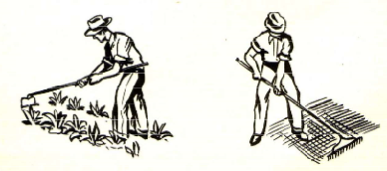

No. 1 PLAN FOR SMALL GARDEN
Will Supply Most of Needed Vegetables for 2 to 4 Persons

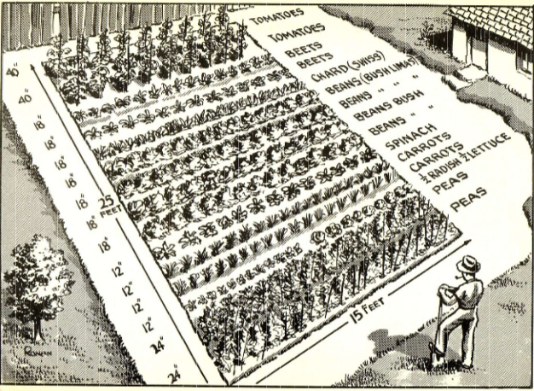

PLANTING AND SUCCESSION CROPS

For Small Gardens
Plan 1 on Page 10 and the Alternate Plan 1 below show gardens which should be started as early in the spring as possible. Then follow through with "succession crops" (examples may be found on pages 13and15). You will be surprised and delightfully amazed at the large quantity of crisp, flavor full vegetables that will reward your efforts.
As explained on pages 4 and 24 you should plan to grow “succession crops". Plan on paper exactly which vegetables you and your family like, study the facts about them on Pages 26 and 27, note the ones to plant early and late and check with the suggestions of replacement crops given with Plans 2 and 3. Then your Victory Garden will produce double the vegetables - and you'll have fun all summer.
These two plans, 10 x 15 and 15 x 25 can be adapted for any small-sized space that measures about 150 to 400 square feet. Do not hesitate to change the selection of items to suit your own individual tastes. The vegetables covered in this plan are comparatively simple to grow. It is assumed, of course, that you will do a good job of soil preparation and cultivation after your crops start to grow.

EXPLANATION OF NO. 1 PLAN

ROW | SPACE ROWS | VEGETABLES | REPLACE WITH
1 | 24 in. | PEAS | CABBAGE (LATE)
2 | 24 in. | PEAS | CABBAGE (LATE)
3 | 12 in | ½ RADISHES ½ LETTUCE
4 | 12 in. | CARROTS | BEANS (BUSH)
5 | 12 in. | CARROTS | BEANS (BUSH)
6 | 18 in. | SPINACH
7 | 18 in. | BEANS (BUSH) | PARSNIP
8 | 18 in. | BEANS (BUSH) | PARSNIP
9 | 24 in. | BEANS (BUSH LIMA) | BEETS
10 | 24 in. | BEANS (BUSH LIMA) | BEETS
11 | 18 in. | CHARD (SWISS)
12 | 18 in. | BEETS | PEAS
13 | 18 in. | BEETS | PEAS
14 | 36 in. | TOMATOES
15 | 36 in. | TOMATOES

Quantities of Seed Estimated to be Required for This Garden. Beans, Carrots, Endive. Kohlrabi, Lettuce, Parsley, Parsnips. Radishes and Swiss Chard-1 packet. Beets and Spinach-2 packets. Onion Sets-1 1/4 pound. Peppers-3 plants. Tomatoes-11 plants.

DIAGRAM OF PLAN No. 2
A Supply for 4 to 7 Persons
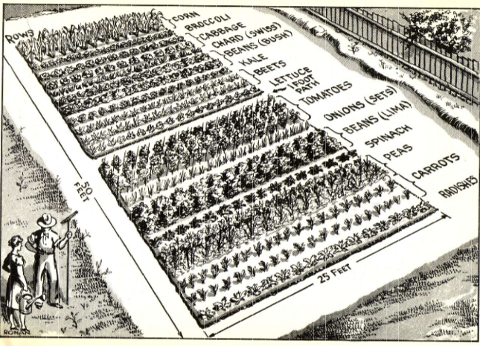

PLANTING AND SUCCESSION CROPS
No. 2 Plan -- 25 x 50 Feet
Here's a Victory Garden big enough for the average American family of four to seven. You will have lots of your favorite vegetables all season long. This plan (1,250 sq. ft.) is adaptable to any size space from 1,000 to 1,400 square feet. Make your garden do double duty by following succession suggestions.
EXPLANATION OF NO. 2 PLAN

ROW | SPACE ROWS | VEGETABLES | REPLACE WITH
1 | 12 in. | RADISHES | LETTUCE
2 | 12 in. | CARROTS | BEANS (BUSH)
3 | 12 in. | CARROTS | BEANS (BUSH)
4 | 24 in. | PEAS | CABBAGE (LATE)
5 | 24 in. | PEAS | CABBAGE (LATE)
6 | 18 in. | SPINACH | ______
7 | 24 in. | BEANS (LIMA) | BEETS
8 | 24 in. | BEANS (LIMA) | BEETS
9 | 12 in. | ONIONS (SETS) | TURNIPS
10 | 36 in. | TOMATOES | ______
11 | 36 in. | TOMATOES | ______
12 | 36 in. | TOMATOES | ______
13 | 12 in. | LETTUCE | RADISHES
14 | 18 in. | BEETS | PEAS
15 | 18 in. | BEETS | PEAS
16 | 24 in. | BROCCOLI | ______
17 | 18 in. | BEANS (BUSH) | PARSNIPS
18 | 18 in. | BEANS (BUSH) | PARSNIPS
19 | 18 in. | CHARD (SWISS) | ______
20 | 18 in. | CABBAGE (EARLY) | CARROTS
21 | 18 in. | CABBAGE (EARLY) | CARROTS
22 | 24 in. | KALE | ______
23 | 36 in | CORN | ______
24 | 36 in | CORN | ______
25 | 36 in | CORN | ______

No. 3 PLAN FOR LARGE GARDEN
Size - 40 x 80 Feet

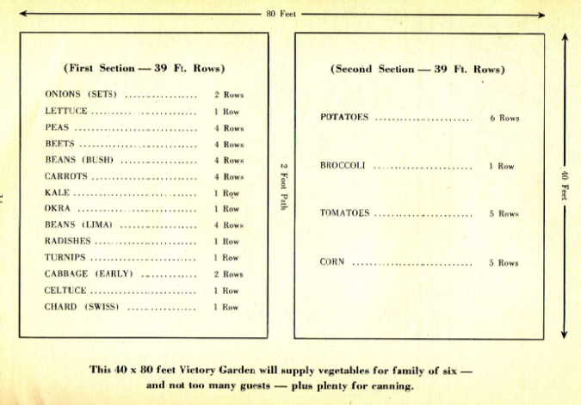

This is a much larger garden than it looks on paper! Measure the space off outside and see how really big it is. Do not plan this size if you are a "week-end" gardener and must do all the work by yourself. It will take the spare time of two people. For convenience in planting, the garden has been divided into two sections. Most of the late maturing crops are in the second section.
EXPLANATION OF NO. 3 PLAN
First Section - (39 Ft. Rows)

ROWS | SPACE ROWS | VEGETABLES | REPLACE WITH
1,2 | 12 in. | ONION (SETS) | CABBAGE (LATE)
3 | 12 in. | LETTUCE | RADISHES
4,5 | 24 in. | PEAS | BEANS (BUSH)
6,7 | 24 in. | PEAS | BEANS (BUSH)
8,9 | 18 in. | BEETS | CARROTS
10,11 | 18 in. | *BEETS | CARROTS
12,13 | 18 in. | BEANS (BUSH) | LETTUCE
14,15 | 18 in. | *BEANS (BUSH) | CHINESE CABBAGE
16,17 | 12 in. | CARROTS | PEAS
18,19 | 12 in. | *CARROTS | PEASE
20 | 24 in. | KALE | ______
21 | 24 in. | OKRA | ______
22,23 | 24 in. | BEANS (LIMA) | BEETS
24,25 | 24 in. | *BEANS (LIMA) | BEETS
26 | 12 in. | RADISHES | SPINACH
27 | 12 in. | TURNIPS | ______
28 to 30 | 18 in. | CABBAGE (EARLY) | PARSNIPS
31 | 24 in. | CELTUCE | ______
32 | 18 in. | CHARD (SWISS) | ______

Second Section - (39 Ft. Rows`)

33 to 35 | 30 in. | POTATOES | ______
36 to 38 | 30 in. | *POTATOES | ______
39 | 24 IN. | BROCCOLI | ______
40 to 45 | 36 in. | TOMATOES | ______
46,47 | 36 in. | CORN (SWEET) | ______
48 to 50 | 36 in. | *CORN (SWEET) | ______

*Plant these items 2 weeks after first planting.

START A COMPOST HEAP

There's a gold mine for your Victory Garden in a compost heap. As it is made up of most of the things you rake up and throw out, it means but little more in work. It makes as fine a humus for your soil as money can buy and yet it costs very little.
Compost is made up of grass cuttings, fallen leaves, flower clippings and other vegetable matter collected from your garden and lawn. You may add potato peelings, bean and pea pods, carrot tops and other clean garbage from the kitchen.
Select an inconspicuous spot in your yard for your compost heap, because, to be frank, it is not very attractive. For a start turn over about six square feet of soil or make a shallow hole (six inches deep will do) of the same size. Then week to week, as you collect clean vegetation throw it all together in a pile. After the pile is about a foot high, add a light layer of top soil to hasten decomposition. Continue with new layers of clippings, grass and soil. Never add diseased vegetation to the heap as it may spread disease. Burn that sort of thing.
Keep the top of the compost heap concave so that rain water, instead of spilling off the top, will soak through and help the mixture to decay more rapidly. If the summer should be dry, soak the heap whenever you water the garden with the hose.
An occasional sprinkling of fertilizer will enrich the compost and speed its decay. Most compost heaps will not have a strong odor, but if yours does, a sprinkling of ordinary lime will clear it up. The addition of acid phosphate once in a while will kill `any flies or other insects that may use it as a breeding place.
Once every six weeks take your spading fork and turn the compost completely over so that the outside parts are placed in the center. This will hasten decay and make for a more even mixture.
The heap should stand over winter before you attempt to use it as you would use other types of humus. Spread it two or three inches thick over your garden before you turn the ground over. If you want to be especially careful in using it, spread it in the bottom of the trenches formed as you are digging the soil. The consistent use of humus will make your ground very productive.
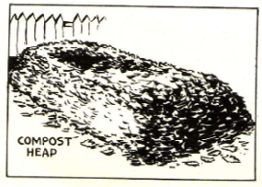

YOU SHOULD HAVE A COLDFRAME

When the inexperienced gardener hears the word "Coldframe" he thinks that only an expert could build one or know how to use it. The facts are that a school-boy could build a satisfactory Coldframe from a packing case cut in half. The main purpose of a Coldframe is to give your plants a head start. You will be able to plant your seeds a month before you could out in the open garden. When the proper planting time comes you have strong seedling plants ready for transplanting, thus gaining 4 to 6 weeks on the regular garden season.

CONSTRUCTION- A Coldframe is really a shallow box with a top cover of glass and no bottom. One three by five feet is a good size, but if you have an old window sash to use for a cover, build your frame to fit it. In all cases the back of the frame should be five or six inches higher than the front so that the rain will run off. The front of the frame should be ten or twelve inches high. The back should be fifteen to eighteen inches in height. Use good solid lumber, one or two inches thick, and cover with a moisture-proof paint. It is apt to rot if you don't.

SOIL-The frame should be set over soil that has been specially prepared. Dig down about six inches where the frame is going to be set. Refill the hole with a loose mixture of garden soil and humus, leaf mold. peat moss or well-decayed compost. Press slightly and level off. Another soil mixture that may be used. is equal parts of sand and peat moss.

LOCATION-Place the frame in a protected place, next to a garage, fence or house. The spot should have good drainage. Face the front of the frame South.

PLANTING- Sow the seeds directly in the Coldframe in rows about two inches apart. During favorable weather raise the glass top an inch or two. When the day is very mild raise the top all the way. If the weather turns cold, close the top and cover with some heavy material such as burlap or an old quilt.

After planting. water lightly so that the soil in the frame will not get too dry. If allowed to dry out, the seeds will not germinate. Watch it carefully. There are three dangers, leaving the sash off on cold frosty nights or days, leaving the sash on, on nice sunny days when ventilation is necessary, and forgetting to water.

Your tender young plants will be ready for transplanting when they are two or three inches high or when they have put out their second set of leaves. Do not disturb the roots any more than you have to.
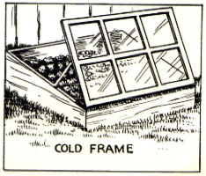

PREPARATION OF THE SOIL

The importance of good soil preparation cannot be overemphasized because this is where your gardening job starts. Unless you are willing to do a good job here, you might as well give up. The difference between a good crop or a poor crop lies in soil preparation. Remember that no vegetable can give you more than it finds in the soil, for the simple reason that everything it gives you comes from the soil. The answer to this is proper soil preparation.

DIG! DIG! DIG!
Vegetables, yes, even down to their roots, have to breathe air. That's why the soil must be loosened and broken up to the full depth of your garden spade. Get at this digging just as soon as the ground thaws, the earlier the better. However, one warning, don't start to dig until the earth falls apart when you squeeze a handful. If it is too moist it will not break up properly.

TWO METHODS TO CHOOSE FROM
First there is single digging, which, to be frank, is as far as most gardeners ever get, and which in most cases is sufficient. You push your spading fork or spade down straight into the ground, not at an angle, using the firm soil at the back of your tool as a pry. Don't cheat! Push the spade in as far as you can go!

DIG IN COMPOST ORFERTILIZER
If you have any compostor other humus or fertilizer, such as horse or cow manure, this is the time to make use of it. Spread it evenly over the ground or place it in the trench that you open up with your spade or fork. Make sure you cover it completely so that it will be down at the level where the roots get their food.

DOUBLE DIGGING FOR POOR SOILS
The next method is known as double digging. They call it "double" because you go two spadesful deep. If you have a good layer of top soil it is not necessary. Do this only when your top soil is thin or the sub-soil is so hard you have to chip it out a little at a time. With this method you should throw the top layer off to one side, the second layer off to the other side. Then you throw the top soil back in the trench first with the second layer in on top. The top layer, which is the poorer soil, may now be improved with humus, manure or fertilizer.
Whichever method you use, don't dig more than a strip four or five feet wide at one time. As you throw the dirt down, hit it with the fork, breaking up the lumps into small pieces. Do this as you go along, and don't let your digging get too far ahead of your raking. Level off the dug over ground with a good iron rake, using teeth to smooth out all depressions.

USE PLOW IF POSSIBLE
We know that most people with small gardens do not have a plow or tractor at their disposal. Here's a tip. If five or six other people in the neighborhood are going to have Victory Gardens, see if you can't get together and hire a farmer or contractor to come in and plow up all of your gardens on the same day. It will probably cost you only $2 each and will save the hardest work gardening requires.
The next operation is to dig a trench about a foot or less in depth and as wide, carry or wheel this soil to the other end of the garden as shown in figure 1. This soil will be used to fill in the void remaining after you have completed your digging.
Figure 2 illustrates the method of turning over tile soil as you dig and fill each trench. The old gardener recommends that you push tile spading fork straight down into the soil to its full length and then turn over each spadeful so as to work in the manure or other organic matter. Break up the lumps as they appear and throw out any large stones, roots or other undesirable matter. Do not dig too deep nor turn up the subsoil.
Work up the soil as you dig and smooth it as much as possible to make raking easy. The main purpose is to level off and pulverize the top three or four inches to make a good bed for your seeds and plants. Victory Garden Fertilizer, at the rate of 3 to 4 pounds for each 100 square feet of garden area should be spread over and raked well into the soil after the digging and leveling operation has been accomplished. Digging is back-breaking, but it is grand exercise. Wait until the garden soil is dry enough before you start to dig. Soil which sticks in a ball when it is pressed in the hand is too wet to be worked - wait until it crumbles under pressure.
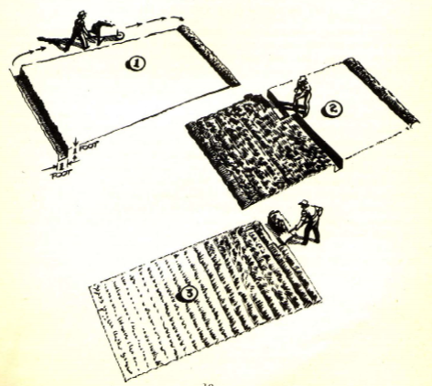

TYPES OF SOIL
CLAY- A clay soil is stiff and heavy; it warms up slowly in the spring and cannot be dug as early as a light sandy soil. However, it is a fine soil once it is proved. It retains plant foods and moisture very well. You can make it an excellent growing soil by adding sand, sifted coal or wood ashes, commercial humus or your own compost. Do this when you turn the soil over, mixing it thoroughly. Apply a light top dressing of lime about ten days after the digging is done, and cultivate it into the surface. (Do not use lime at the same time you apply manure a fertilizer.) This type of soil is better if turned over in the fall (but not raked level) so that it is in a rough state during the winter. It will then break up into loose particles much more easily in the spring.
SANDY- A sandy soil that has been improved properly, makes a fine bed for most vegetables. It does not retain moisture and nourishment until this has been done. If your soil is sandy, plant a cover crop such as buckwheat, rye or oats in the fall. Then in the spring tum the cover crop under. You will also have to add considerable quantities of humus, peat moss or your own compost. You will find that it will improve greatly each season with these treatments.

USE OF FERTILIZERS
Fertilizers have two purposes-first, to improve the soil; second, to hasten growth. Your first use of a fertilizer will serve both purposes if you apply it when you first turn the soil over, or better still, about a week before planting, work it well into the upper part of the soil.
Nitrogen, potash and phosphorus are the essential elements that are lacking in sufficient quantities in most garden soils. They should be replaced with a good commercial fertilizer. One that is especially good to use at the beginning of the season is a commercial mixture. This year, because of war conditions, the standard formula for chemical fertilizers, will consist of three units of nitrogen, eight units of phosphorous and seven units of potash. This will be known as “Victory Fertilizer", and will be sold in lots ranging from 5 pounds to 100 pounds. Use about 5 pounds of this to 200 square feet; however, he guided by your dealer in your choice of fertilizer, and follow directions given with your purchase.
Cow manure and horse manure are both good for general use if you can obtain them. Other good fertilizers are bone meal, cottonseed, soybean meal and tankage. These release their elements much more slowly than commercial fertilizers and therefore will not be of much use in forcing quick growth.

USE OF LIME
Do not use lime unless you really know that it is needed. You can find out if your soil needs it very easily. Ask your druggist for a piece of Litmus paper. Dig up some soil and place it around the paper. If the paper turns dark red, you do not need lime. If the paper turns a bright red, lime should be used because the soil is sour. Use a finely powdered hydrated lime, and spread it sparingly over the surface of your garden, cultivating it into the top few inches of soil.

HOW TO SOW YOUR SEEDS WITH CARE

SELECTION OF SEED
You will miss a lot of preliminary fun if you do not send away for a few seed catalogs. They will, of course, he a guide in helping you decide which of the many different varieties you will want to grow. Don't hesitate over the relative quality of one brand over another. You will find that all packaged brands of seeds from reputable growers will be good. Total seed cost is very little, so don't buy the cheaper grades or you will be disappointed in the results. Good seeds will give you more plants and healthier plants per ounce than cheap seeds. However, before you order any, or buy any from your local store, be sure that you know just what quantities you will need.

GOOD SOWING PAYS DIVIDENDS
A great deal of the joy you will have from working in your garden later on, as well as the amount of food you will eventually raise, depends to a great extent upon the way you plant your seed. The first consideration is to be sure that you do not plant any seeds ahead of their scheduled planting time.
After you have properly prepared and leveled off your soil, you are ready to start sowing. Get a good, strong cord, as long as your longest row in the garden, with a one-foot stake tied at each end. Use this cord, pulled taut. as a guide in laying out rows that are as straight as arrows.
Now study the directions for planting the seeds you are going to put in the first row … and FOLLOW THEM FAITHFULLY! If the directions say plant the seeds one inch deep make your furrow one inch deep. If the grower says plant the seeds two inches apart do as he recommends.
The larger seeds, such as Peas and Beans, can be placed in the furrow one at a time. If the seeds are very fine, cut a small piece off the corner of the packet and tap the seeds out gently, a few at a time.
To make shallow furrows use a small stick or the handle of your hoe or rake. For deeper furrows use the corner of your hoe.

KEEP DISTANCE BETWEEN ROWS
It does not pay to place the rows closer together than the instructions recommend, although many gardeners do this in order to crowd more vegetables into a limited space. When rows are too close together it is impossible to cultivate them properly after the plants have grown. Under such circumstances it is possible for a row of larger plants to completely cover a neighboring row of smaller plants, either killing or preventing the latter from maturing.

FILL IN AND TAMP
After your seed is in, take up the guide cord and fill in the furrow to a point slightly above the level of the surrounding ground. Next. with your hoe tamp the earth down gently but firmly. Remember that too much pressure at this time is worse than none at all. Keep careless feet from trampling upon your hidden seeds by placing a spare stake at both ends of the row.
FOLLOW PLANTING INSTRUCTIONS - IT PAYS!

CULTIVATION ENCOURAGES GROWTH

REASONS WHY
The main purpose of this favorite garden exercise, is to make it easier for the plants to get their food, moisture and air out of the soil. The second purpose is to protect them from their most relentless enemy, the weeds. A weekly scratching of the top surface of the soil (that’s all cultivation really is) keeps the ground from caking and baking. The loose soil that results from it acts as an insulation blanket that helps to keep the sun from stealing the moisture out of the ground.

WEEDS ARE ROBBERS
Weeds are the worst robbers that ever entered a garden. They steal the things your crops must have-moisture and food! If allowed to grow too tall before they are pulled or cut down they also steal the plants~ life-giving sunshine.

USE GOOD TOOLS
The cultivator that saves the most labor is the prong type. With it you use a pulling, scratching motion that will not tire you as fast as the chopping motion necessary with a garden hoe. The prong type is handier in getting close to the plants without damaging them as is apt to happen with a hoe. You will, however, find the hoe better for chopping down the weeds if you allow them to get too tall. For large gardens you will want a wheeled cultivator such as used on small farms.

CULTIVATE LIGHTLY
It is not necessary or desirable to dig your cultivating tools into the ground more than about an inch. If you go deeper you are apt to damage the plants' roots and do more harm than good. Even with light cultivation don't get too near the plant roots. Use your hands to pull out weeds that are near plants.

USE MULCH BETWEEN ROWS
A simple but effective way to keep weeds down and reduce the area you have to cultivate, is to spread a thin layer of grass clippings or straw between the rows. A final tip-cultivate as often as you can soon after rainstorms. The earth is softer and requires less work to loosen up. Weeds pull out much easier after a rain.

YOUR CROPS NEED WATER
If you are lucky enough to get a good rain once a week you will not have to use the hose. If you are not there is nothing to do but haul out the hose and give everything a good soaking. Never give your garden a light soaking as that has a tendency to attract the roots to the surface where they will be damaged during the next dry spell. Use a rotating arm sprinkler to save time and do a better job.
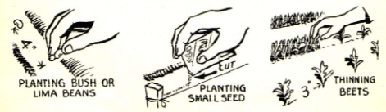

PLANTING TIME AND MATURING TABLE

Planting dates are for localities with last Spring frost due about April 15th. Adjust to your locality by checking with map on Page 5.

VEGETABLE | Matures in | Plant
BEANS (BUSH) | 45- 65 Days | May 15
BEANS (LIMA) | 60 – 75 Days | May 15
BEANS (POLE) | 45 – 65 Days | May 15
BEETS | 50 – 100 Days | May 1
BROCCOLI | 85 – 90 Days | May 1
CELTUCE | 90 – 100 Days | May 1
CARROTS | 60 – 110 Days | Apr. 15
CABBAGE (EARLY) | 90 – 120 Days | Apr. 15
CABBAGE (LATE) | 100 – 135 Days | May 15
CHARD (SWISS) | 50 – 120 Days | May 1
CORN (GOLD BANTAM) | 75 – 90 Days | May 15
KALE | 90 – 100 Days | Apr. 15
LETTUCE | 60 – 90 Days | Apr. 15
OKRA | 90 – 140 Days | May 15
ONIONS (SEEDS) | 140 – 160 Days | Apr. 15
ONION (SETS | 45 – 75 Days | Apr. 15
PARSNIPS | 140 – 160 Days | May 1
PEAS | 75 – 100 Days | Mar. 15
POTATOES | 120 – 140 Days | Apr. 15
RADISHES | 30 – 65 Days | Apr. 15
SPINACH | 60 – 80 Days | Apr. 15
SQUASH (BUSH) | 60 – 70 Days | June 1
TOMATOES | 150 – 170 Days | May 15
TURNIPS | 60 – 75 Days | Apr. 15

SUCCESSION OF CROPS VERY PROFITABLE
You can increase the returns from your Victory Garden by 50% if you carefully plan on paper, just what crops you will plant to replace those that are harvested first. This is called succession of crops. It not only makes your garden space do double duty if it is small, but it will also enable you to have a consistent supply of the same vegetables for your table during the summer and early fall.
For example, make successive plantings every two weeks of lettuce, peas, beans, spinach, carrots, beets and corn until several crops are coming in. In this way you will get at least two or three crops to keep you well supplied.
You can get the same results by planting -at the same time, vegetables that mature at different times, but it is more difficult to control the variety with this method.
The earlier you get your garden started (not before the ground is workable, of course) the more crops you will be able to raise in succession. This is the main reason so many gardeners make plantings in a Coldframe before the outdoor planting season starts. The use and construction of a Coldframe is outlined on Page17.
The Victory gardener, especially the one with a small family and a small plot, should bear in mind that it is better to plant a small amount every two or three weeks, than it is to plant a big quantity all at once, because he will not be able to use all of the resulting crops while they are young and tender.

REMEMBER WHEN FIRST FROSTS ARE DUE
In planning successive crops, you should check on the time the first autumn frosts are due in your locality. For instance, if a frost usually comes around October l5th, then you should make your last sowing about 1st of August for such crops as dwarf beans, beets, Swiss chard, carrots, endive and lettuce. Since they take a shorter period to mature, radishes and spinach could still be sown as late as September 1st. These dates will serve you as a guide. Adjust your plantings accordingly if the first severe frost comes earlier or later.
Don't be content with one crop. Before you actually start work outdoors, get pencil, paper and charts and schedule the dates of plantings so that you will be assured of a constant supply all summer of a good variety of tender vegetables.
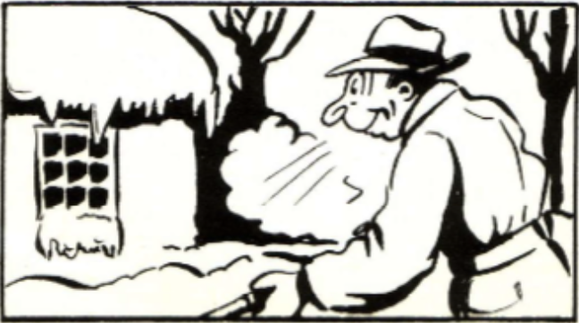

CERTAIN VEGETABLES REQUIRE SUPPORTS
Peas, Pole Beans, Tomatoes and other heavy or tall growing plants such as Egg Plants, need good strong supports to grow properly. These supports should be set in the ground while the plants are quite young. If you wait until they really need the supports, you will harm the roots of the plants when you put them in. The supports should be strong enough to bear the weight of the ripened vegetables. Even if the supports themselves are strong, they may be pulled over if you do not place them deep enough in the ground.
Good, strong supports, placed securely in the ground will keep your rows clear for cultivation and the vegetables off the ground where they may rot before they ripen. Sunshine will also reach all parts of the plants and thus hasten ripening.

TWO TYPES FORTOMATOES

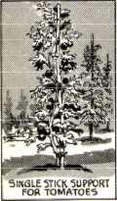 | SINGLE POLE  Should be 3 or 4 ft. above ground and 1 ft. in the ground. Poles should be at least 1 in. thick. Place in ground close to plant when young. Tie plant to pole as it grows. This is type commonly used.
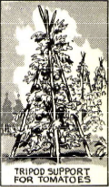 | TRI-POD TYPE  Use three 4 ft. poles tied together at top. Place top over center of individual plants and tie up branches as they grow or place the tri-pod in the center of three plants and tie a plant to each pole as it grows. Push tri-pod poles few inches into ground.

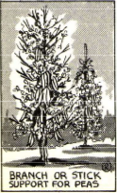 | BRUSHWOOD STAKES FOR PEAS  Use good, bushy pieces of shrubs or branches. Push 8 inches in ground with 3 or 4 ft. above ground. Leave branches on brush. Peas will climb up of own accord, although you may have to start them doing so at first
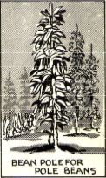 | STRONG POLES FOR POLE BEANS AND POLE LIMA BEANS  Use poles 7 or 8 ft. tall, 2 inches wide at base. Set firmly 1 or 1 1/2 ft. in ground before you plant the seeds. Leave short ends of branches on poles to help plants climb. Tie plants to pole as they start to grow.

FACTS ABOUT YOUR FAVORITE VEGETABLES

(Planting Time Is Average for Eastern States)

BEANS (BUSH)
A "Must" for every garden. Great producer and easy to grow. Likes sandy loam. Sow early in May or when the soil is warm. Plant every two weeks up to August 1st for continuous supply. Rows 18 inches apart. Seeds two to three inches apart and two inches deep. One pkt. for 25 ft. row.
BEANS (POLE)
Very productive! Matures later than bush beans but bear longer. Plant second week in May; not later than June l5th. Place rough 7-foot poles at least I foot in ground about 3 feet apart. Sow 6 seeds around each pole. Thin to 3 or 4 of strongest plants. One pkt. for 15 poles.
BEANS (BUSH LIMAS)
One of the most succulent of all garden favorites! Likes rich sandy soil. Plant about May l5th with the eyes down in rows two and one-half feet apart and seeds 5 inches apart. Thin to 10 in. Never cultivate or touch plants when wet. 25 ft. row requires 1 1/2 pkts.
BEETS
An old time hardy favorite that requires little attention. A good storage crop for winter use. Likes a rich well-loosened sandy loam. Sow every three weeks to end of July for continuous supply. Sow seeds 1 in. apart, 1 in. deep in rows 18 in. apart. Thin to 3 in. Use tops for greens. One pkt. for 25 ft. row.
BROCCOLI
Comparatively new but not difficult to raise. Start seed in Coldframe, March 15th. Transplant about April 30th. For later crop sow seeds May 30th in rows 2 ft. apart. Thin to 13 in. Plants will continue to bear after first cutting" One pkt. for 25 ft. row.
CELTUCE
Another newcomer you will like. Delicious as salad or cooked. Grows easily and quickly. Has four times more Vitamin C than lettuce. Use the leaves and inside meat of the stalk. Plant about April 3Oth in rows 2 ft. apart. Thin to 6 in. One pkt. for 25 ft. row.
CARROTS
They will have a high ration coupon point value when bought in cans, so it pays extra to grow them. Soil must he deeply worked and loose. Sow April l5th in rows 1 ft. apart and 1 in. deep. Thin to 3 in. Sow every two weeks to July 1st for continuous supply. One pkt. for 25 ft. row.
CABBAGE (EARLY)
Sow seeds indoors late in February and transplant early in April, or buy plants at that time. Plant in rows 18 in. apart with 18 in. between plants. They like a light dry soil. Will mature in about 90 days. Cultivate lightly as roots are near surface.
CABBAGE (LATE)
Sow this variety outdoors in May or June. Transplant in July, or buy plants at that time. This type likes heavier richer soil. Will mature in October or November. Plant in rows 2 ft. apart with 18 in. between plants. If cabbage moth appears, use rotenone spray.
CHARD (SWISS)
Very tasty. You can cut and it comes again and again. Many people prefer it to spinach. Plant rows about 18 in. apart. Thin plants to 6 in. Sow in April or May. One pkt. for 25 ft.
CORN (SWEET)
Be sure to have some if your garden is big enough. Plant May 1st to May l5th when soil is thoroughly warm. For a continuous supply sow every two weeks until end of July. Plant in rows 3 ft. apart with seeds every 4 in~ Thin to 12 in. Or plant in hills 3 ft. apart each way, allowing 2 or 3 plants to remain in each hill. Plant in number of short rows instead of a few long ones, as an aid to pollination. One pkt. for 4 twenty-five ft. rows.
KALE
It is full of vitamins and delicious when cooked. Sow seeds from April l5th to August l5th. Frost improves its flavor. Plant in rows 3 ft. apart. Thin or transplant the seedlings to 12 in. apart. One pkt. for 25 ft. row.
LETTUCE
America's favorite salad! It's crisp, tender and high in vitamins and minerals. For a head start plant seeds indoors or in a Coldframe about March 1st. Transplant or sow seeds outdoors as soon as soil can be worked. Sow every two weeks until August for continuous supply. Plant in rows 12 in. apart; thin to 6 in. One pkt. will sow two 50 ft. rows.
OKRA
A vigorous grower not found in enough gardens. Easy to grow. Young pods are delicious as cooked vegetable or for use in soups and relishes. Plant May l5th in~ rows 2 ft. apart. Thin plants to 18 in. 2 pkts. for 25 ft. row.
ONIONS (SEED)
They like a well-tilled, well drained soil. Plant as soon as ground can he worked in rows I ft. apart and ~ in. deep. Thin to 3 in. (or more if larger types are grown). Bend tops down (but don't break off) when bulbs are full grown to hasten ripening a good crop for storage. 1 pkt. for 25 ft. row.
ONIONS (SETS)
These will mature much more quickly than seeds. Can be thinned out and used as scallions in about 6 weeks. Plant April 13th 2 or 3 in apart in rows I ft. apart, about 1/2 in deep. One pint will do two 25 ft. rows.
PARSNIPS
If you ever tasted fried tender parsnips, you would grow some most certainly. Requires a deeply worked soil. Sow about May 1st in rows 2 ft. apart and ~ in. deep. Thin to 4 in. Frost improves their flavor. A good crop for winter storage. One pkt. for 25 ft. row.
PEAS
No other vegetable is so universally popular and with good reason. A freshly picked garden grown pea is unsurpassed for flavor and tenderness. Plant early in March as soon as ground can be worked. Plant in rows 2 ft. apart, 2 in. deep. Place seeds 2 in. apart. Do not thin out. Use brushwood supports, placed in ground when seed is planted. Repeat plantings every two weeks until late May. Use 1/8 lb. of seed for 25 ft. row.
POTATOES
The gardener's bread and butter. They like a rich sandy loam with plenty of humus. Buy good seed potatoes. Cut them into pieces with 1 or 2 eyes. Plant April l5th in rows 30 in. apart, 12 in. apart and 4 in. deep. You will need about 2 lbs. for a 25 ft. row.
RADISHES
They like a sandy loam soil but will grow well in any type. They grow quickly especially if a quick-acting fertilizer is applied. You should sow them every 2 weeks from April 15th to August 15th. Plant in rows 1 ft. apart, 1/2 in. deep. Thin to 2 in. One pkt. for 25 ft.
SPINACH
An easy crop to grow with good soil and cool weather. Plant your first crop April l5th in rows 1 1/2 ft. apart, 1/2 in. deep. Thin to 5 in. apart. Sow every two weeks until June l5th. Plant your seeds for a fall supply from August l5th to September l5th. One pkt. for 25 ft.
SQUASH (BUSH)
Easy to grow and prolific. Delicious when fried, baked or stewed. Plant in hills 3 ft. apart each way. Sow seeds in each hill I in. deep. Thin to 4 of strongest plants. One pkt. will do for 10 hills.
TOMATOES
A crop that seldom fails. It likes almost any kind of soil. You can sow seed indoors about March 15th, but most gardeners prefer to buy plants and set them out around May l5th. Plant them singly in hills at least 3 ft. apart each way. The tomatoes will ripen better if you tie the plants as they grow, to good sturdy supports about 3 ft. high. Pinch off side shoots as they appear, to make the fruit larger.
TURNIPS
A good substantial tasty dish. Hardy and easy to grow. Plant April 15th in rows 1 ft. apart. Thin to 4 in. A grand winter storage crop. Make a 2nd planting in July or August. 1/2 pkt. for 25 ft. row. This is an excellent crop for winter storage.

VITAMIN VALUES IN VEGETABLES

M --- means medium source; H --- means high source

 | Vitamin A | Thiamin Vit. B1 | Ascorbic Acid Vit. C | Riboflavin Vit. G
BEANS (LIMA) | - | H | - | M
BEANS (BUSH) | H | M | M | -
BEET GREENS | H | - | H | -
CABBAGE | - | M | H | M
CARROTS | H | M | - | M
CHARD | H | - | - | -
CORN | M | M | M | -
ONIONS | - | M | M | -
KALE | H | M | H | H
LETTUCE | H | M | - | M
PARSLEY | M | M | H | M
PEAS | H | H | M | H
RADISHES | - | M | M | -
SPINACH | H | M | H | M
TOMATOES | H | M | H | -
TURNIP GREENS | H | M | H | H
TURNIPS | - | - | H | -
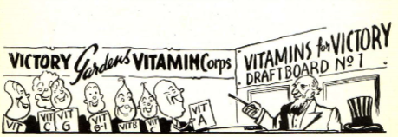

THE USE OF INSECTICIDES

Prompt and proper action will control your garden pests to a great extent. To this end you must view your garden with an inquisitive eye from day to day. Examine the undersides of your spinach for aphids, look for the large green tomato worm. If any of your vegetables look sick, find out why and take corrective measures at once. If you can't diagnose the case yourself, usually the other gardeners in your vicinity can help. Your County Agricultural Bureau is always ready to be of service to you.
The destructive insects that invade your garden are divided into two classes. The chewing insects obtain their food by chewing the leaves, fruit, flowers and stems of plants. The second class, called sucking insects, live on plant juices.
The first group of chewing insects are controlled by spraying or dusting the plants with stomach insecticides, such as lead arsenate, calcium arsenate, "Dutox" and rotenone. Some of the best known pests of this group are coddling moth Caterpillar, cankerworms, cabbage worms, cucumber beetles, Mexican bean beetle and several species of grubs.
The second group of sucking insects and mites are controlled by contact insecticides. Some of the most important contact insecticides are lime-sulphur, dormant oil, nicotine sulphate and rotenone or pyrethrum dusts and sprays. The application of this type of insecticide must be very thorough and carefully done. Unless there is actual contact with the dust or spray, the insect will not be killed.
There are low forms of plant life known as fungi that live on growing plants as parasites. These are the cause for blights, rot, leaf spot and mildews. Unfortunately little can be done to cure these diseases. Here prevention is worth the proverbial pound of cure. If you dust and spray thoroughly and consistently, keeping your plants in a healthy condition, you have done all that any one can do.
Generally speaking, dusts are more economical than sprays for the small garden. Whenever possible, use dusts and sprays that are non-poisonous, especially where it is necessary to spray or dust parts of the vegetable that are to be eaten.
It is necessary to consider your weather conditions before you apply dusts or sprays. Naturally, if it rains shortly after, the chemical is washed away and the treatment must be repeated.
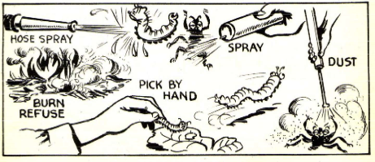

REMEMBER THE IMPORTANT "DO'S"

DO prepare your soil! YOU can't live without food? neither can a plant! You need air - so does a plant! (right down to its roots). So, break that soil up. Make it rich with humus and fertilizer. | 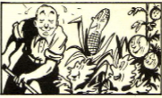
DO cultivate your garden! When you were young and tender you had a mother's care. If you want your plants to up and be nice to you, Shower them with loving care (and cultivation) | 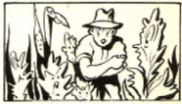
DO use water! You be able to hear your when they're crying for water? but they'll dying just the same! A good soaking rain, or get out the hose! | 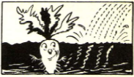
DO make a compost heap! It's nature's gift to gardeners and a lazy man's joy! It saves you the work of burning up or carting out waste material. And how the plants love it! | 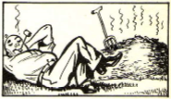
DO plan your garden on before you start! It will save you money, time, and lots of work. It will keep you from making many mistakes. You are going to have a big family of this summer? better plan for now! | 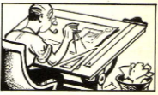
DO have a garden this summer! No vegetable ever tasted so good as one you raised yourself. Make your contribution helping towards helping win the war! Get the biggest bargains in vegetables, health and new happiness - all practically for the sweat on your brow and the soil on your hands! | 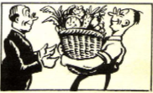

REMEMBER THE IMPORTANT "DON'TS"

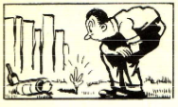 | DON'T think gardening mysterious or difficult! It takes planning? it takes work - but a lot less than you may think it does. With a little luck and a little rain there is very little hard work left to do after you have prepared the soil and put your seeds in!
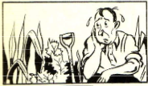 | DON'T kill yourself! That sounds silly after just saying that gardening isn't difficult. It does take a certain amount of time. If you plan too much space and do not have the time to take care of it - well, that's silly!
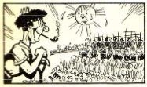 | DON'T fail to plan succession crops regardless of the size of your garden! If you put everything in all at once you will have weeks when you have more than you can and other weeks when you won't have anything! Be Scotch - get or three out of every row!
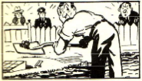 | DON'T cheat! When you are turning over the soil this Spring, don't push your spade in half - or three-quarters of the way - push it in all the way! All crops broken up soil. Carrots, parsnips, etc., won't half try if you don't make it for their roots to spread downward.
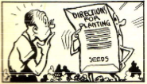 | DON'T think you more than the man grew your seeds! You find directions on the back of every packet of seeds. Read them carefully follow them faithfully! No "expert" can give directions for planting the hundreds of varieties of seed available. The man who grows 'em knows best.

TIPS FOR GARDENERS VICTORY

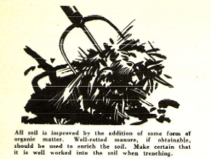  All soil is improved by the addition of some form of organic matter. Well-rotted manure, if obtainable, should be used to enrich the soil. Make certain that is well worked into the soil when trenching. | 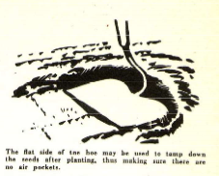  The flat side of the hoe may be used to tamp down the seeds after planting. thus making sure there are no air pockets.
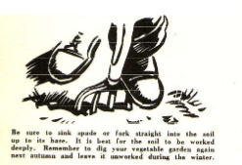  Be sure to sink spade or fork straight into the soil up to its base. It is best for the sod to be worked deeply. Remember to dig your vegetable garden again next autumn and leave it unworked during the winter. | 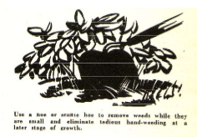  Use a hoe or scuttle hoe to remove weeds while they are small and eliminate tedious hand-weeding at a later stage of growth.
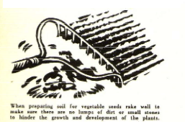  When preparing soil for vegetable seeds take well to make sure there are no lumps of dirt or small stones to hinder the growth and development of the plants. | 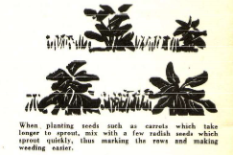  When planting seeds such as carrots which take longer to sprout, mix with a few radish seeds which sprout out quickly. thus making the rows and making weeding easier.
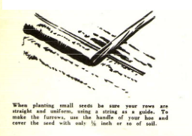  When planting small seeds be sure your rows are straight and uniform using a string as a guide. To make the furrows, use the handle of your hoe and cover the seed with only 1/8 inch or so of soil. | 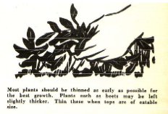  Most plants should be thinned as early as possible for the best growth. Plants such as beets may he left slightly thicker. Thin these when tops ate of eatable size.

Grateful acknowledgment is made to the Department of Agriculture for its kindly courtesy and cheerful cooperation in furnishing facts and figures.

